Updating Trojan Using Files Downloaded From the Internet
You can now download your Trojan files from the Internet instead of from tapes! The requirements to use this new function is as follows:
- Windows PC using Windows XP
- PcLink version 1.9 or higher
- Datacon version N(100) or higher
- A Trojan Benefit Downloader program CD from Trojan to be loaded on a single pc only.
NOTE: Downloading from the Internet MUST be performed from the same PC every month!!

Trojan will help you install their program after you receive their CD.

- From the Main Menu, SELECT Insurance>Trojan Updates>Copy Trojan data to your disk

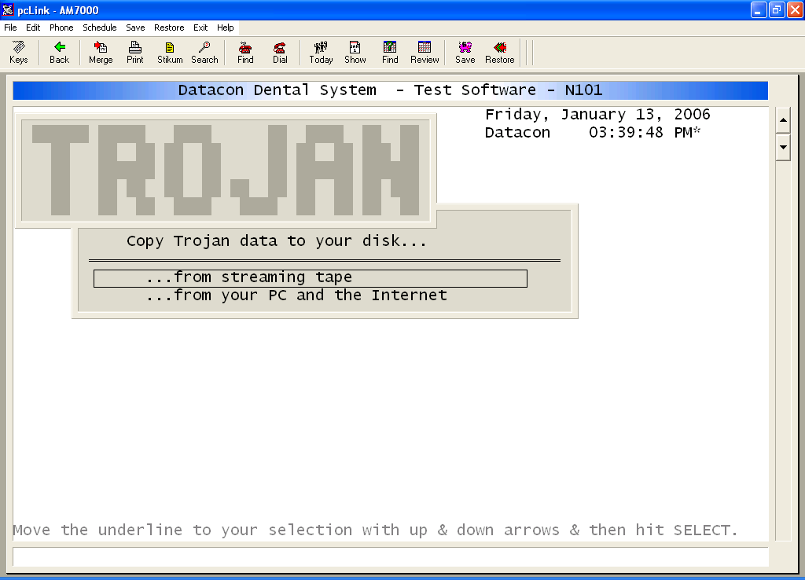

- SELECT …from your PC and the Internet
- The system will delete the old Trojan files and then will tell you to press RETURN to begin transferring Trojan Data

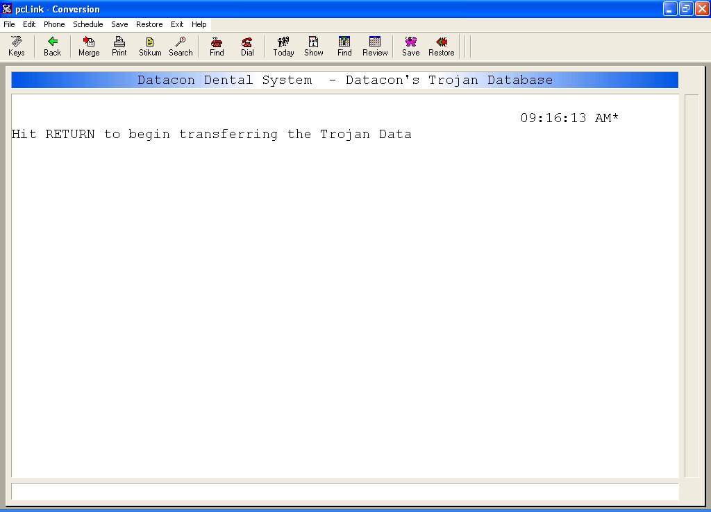

- The Trojan Benefit Update Downloader will appear

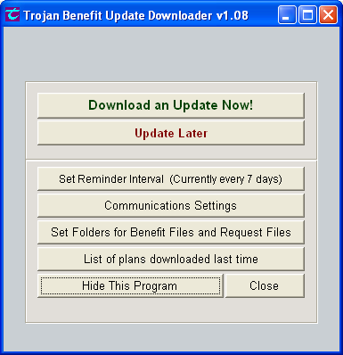

- Click on Download an Update Now!
- If you get an error message saying the server name or address could not be resolved, you are having a problem with your Internet connection.
- The system will automatically take you to the Trojan’s Benefit Update Program. Click Download Now

If they are not using the right pc they will get an error message “Error: Resource file not valid, would you like to overwrite with a new empty file?” Answer No and get them to right pc.

- The program will start downloading files from the internet to your PC

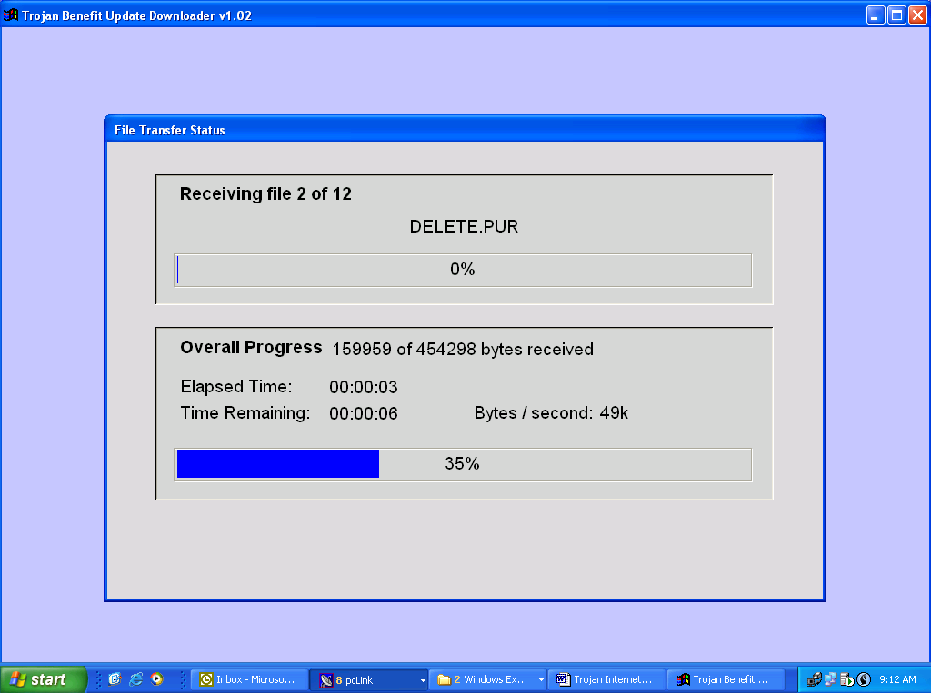

- When it finishes downloading you will get the following screen:

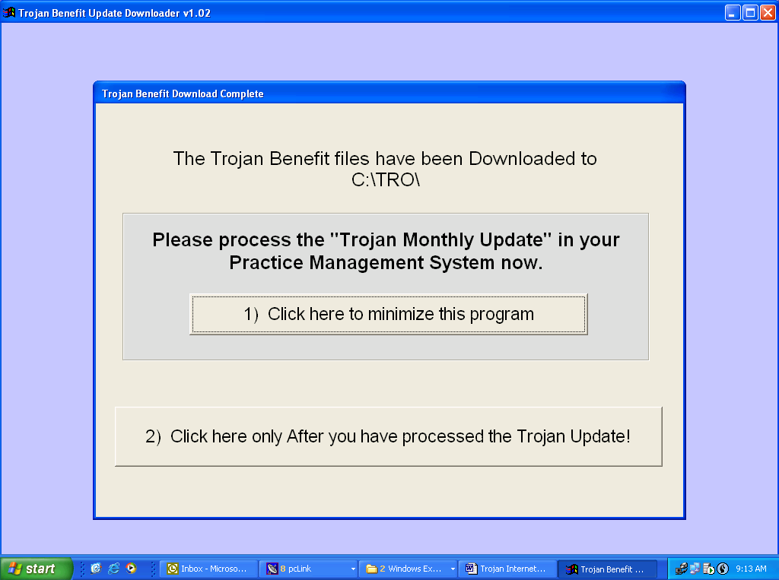

- Click 1) Click here to minimize this program. You will be back on Datacon; answer “Y” to “Has the Trojan data been downloaded to this PC?”
- The system will then start downloading the Trojan files from the PC to the Alpha Micro

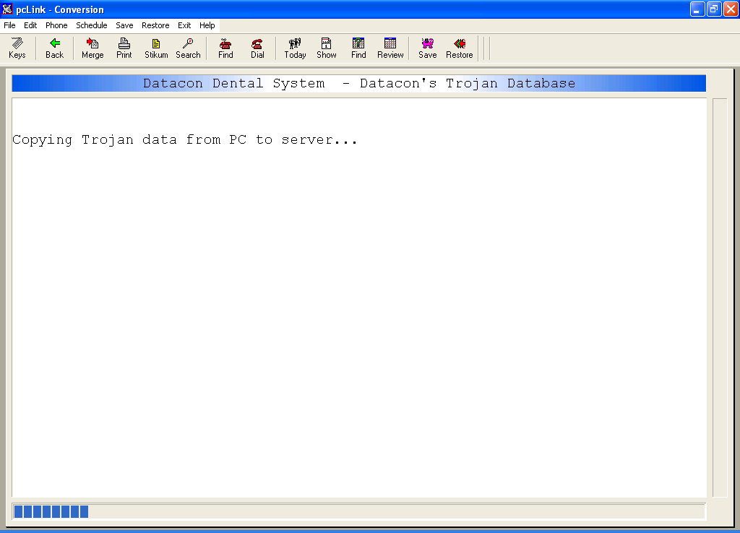

- When it finishes downloading to the Alpha Micro, the system will prompt “Be sure to update your files with this new data.” Click OK and EXIT back to your Main Menu.
- Before you go home in the evening, from the Main Menu, SELECT Insurance>Trojan Updates>Use Trojan data on your disk to update your files

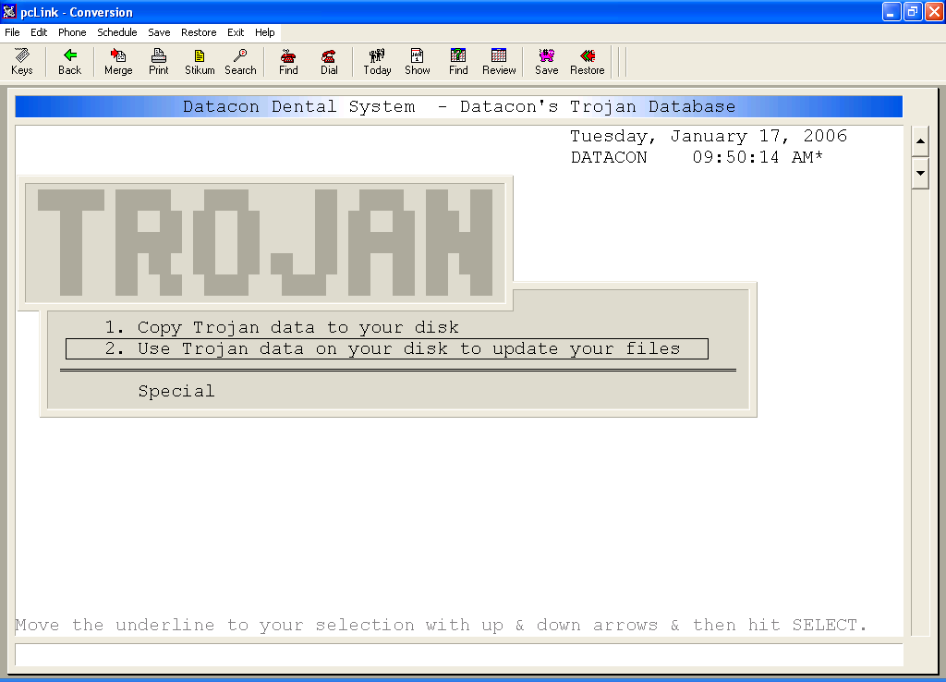

- The next morning, you can check your Trojan update by checking your Error Log. At the Main Menu, SEARCH and type ERRLOG, press ENTER and SELECT Review Error Log

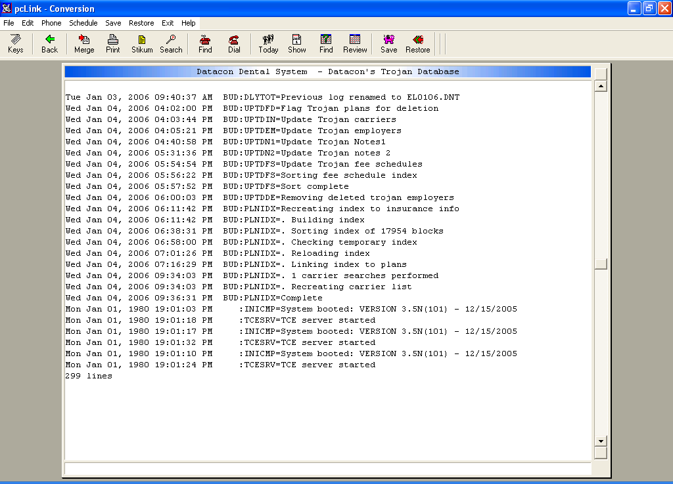

- The Trojan update starts with Flag Trojan plans for deletion and goes through all the steps listed and must end with PLNIDX-Complete
- If you don’t see these steps or if you get the message when you log in that Trojan was started and not complete, please call Datacon.

- On your Windows Taskbar, click on the Trojan Benefit…
- Click on 2) Click here only After you have processed the Trojan Update! Then click YES to Confirm that you have processed the update in your Practice Management System

Updated
5/27/08 lla

